Assignment 2- Case Study

Stage 3 Lab Activities

SmartCare Domain Modelling
AI OFF -> AI ON -> COMPARE -> VERIFY | 1 hour

A - Requirements Review
Highlight nouns, verbs and business rules in SmartCare v0.2.
Nouns: Patient, Practitioner, Appointment, Patient Record, Practitioner Record, Appointment Status, Appointment History, date/time, patient name, practitioner name, date range, count
Verbs: Create, book, reject, assign, change status, cancel, retain, display, search, match, report, count.
Business Rules:
- A practitioner cannot hold two appointments at the same date and time (FR-04).
- A booking with an empty patient or practitioner name is rejected, naming the missing field (FR-05).
- A new appointment starts with a status of Booked (FR-03).
- Cancelled and past appointments are retained, not removed (FR-08).
- Patient search is a case-insensitive partial match (FR-11 amended).
- The appointment count includes Booked and Attended only (FR-12 amended).
- Patient, practitioner and date/time never change after creation; only status changes (NFR-06 amended).
- There is no edit capability: correcting an appointment means cancelling and rebooking (Stage 2 assumption).

B - Candidate Classes
Record candidate concepts, supporting requirements, state and behaviour.
Accepted
Patient (FR-01, FR-05, FR-11). State: name. Behaviour: matches a search term, validates its name.
Practitioner (FR-02, FR-05). State: name. Behaviour: validates its name.
Appointment (FR-03, FR-06, FR-07). State: patient, practitioner, date/time, status. Behaviour: cancels itself, changes its status, answers questions about itself.
AppointmentBook (FR-04, FR-08 to FR-12). State: the appointment records. Behaviour: books, checks clashes, lists, counts.
PatientRegister (FR-01, FR-11). State: the patient records. Behaviour: creates a record, finds by name.
Deferred
PractitionerRegister (FR-02). the storage need is real but nothing searches or lists practitioners, so the class would have one operation and nothing asking for it. Carried as an open question.
Not modelled as classes
Appointment status. A fixed set of four permitted values used by FR-03, FR-06 and FR-07. Held as an attribute of Appointment with the values as module constants.
Name. An attribute of Patient and Practitioner, with no identity or behaviour of its own.
Clinic. Multi-clinic operation is out of scope and no requirement gives it state or behaviour.
Database and persistence. A design concern, and an open question rather than a confirmed requirement.
Notification. Patient-facing notifications are explicitly out of scope.
User, login and role. Authentication is an open question; all users are assumed to be trusted staff.
Appointment history. The retained contents of the AppointmentBook rather than a thing of its own (FR-08).

C - CRC Cards
Create CRC cards for Patient, Practitioner and Appointment.

Patient
Responsibilities | Collaborators
Know its own name (FR-01)
Report whether it matches a search term (FR-11) | PatientRegister
Report whether its name is valid (FR-05) | AppointmentBook

Practitioner
Responsibilities | Collaborators
Know its own name (FR-02)
Report whether its name is valid (FR-05) | AppointmentBook

Appointment
Responsibilities | Collaborators
Know its patient, practitioner, date/time and statuss (FR-03) | Patient, Practitioner
Change its own status to Attended or Did Not Attend (FR-06)
Cancel itself (FR-07)
Report whether it is Booked (FR-09), belongs to a practitioner (FR-10), occurs at a time (FR-04) or falls in a range (FR-12) | AppointmentBook

D - UML Model
Draw classes, attributes, operations, associations and multiplicities.
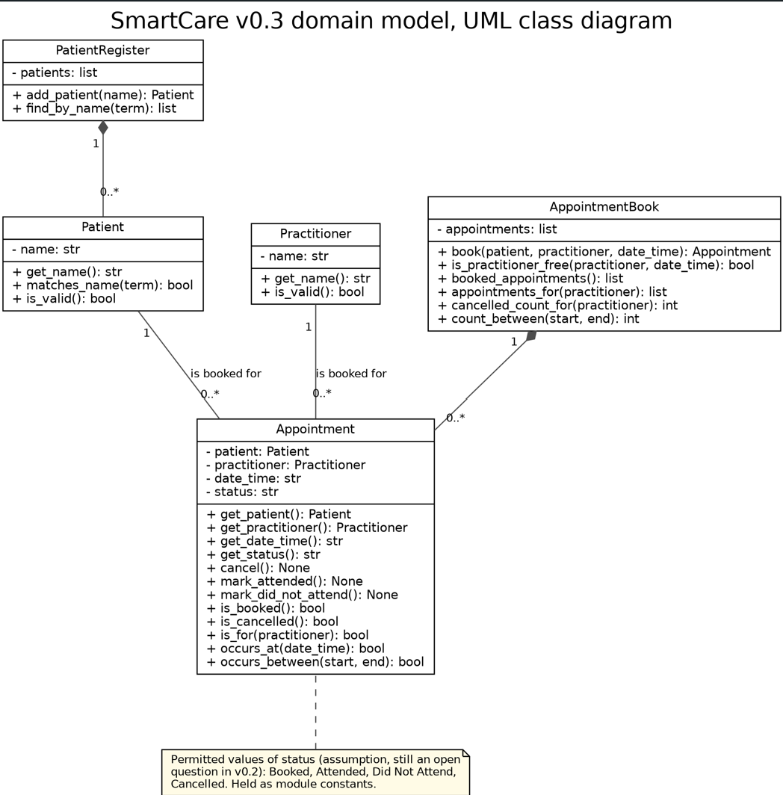
Seen with justifications in the workbook.

E - AI Design Review
Ask AI to suggest classes and relationships using only confirmed requirements; require supporting requirement IDs.
Twelve proposals were returned. Five are tabled in the SmartCare v0.3 Domain Model Workbook

F - Compare and Decide
Record at least one accepted, modified and rejected AI suggestion.
Decision | AI suggestion | Outcome
Accepted | Separate the appointment collection from the appointment itself | FR-04, FR-09, FR-10 and FR-12 each reason across the whole set, which no single Appointment can do. Without this class, four confirmed requirements have no owner. AppointmentBook added.
Modified | AppointmentManager handling booking, persistence and display | Booking coordination is justified by FR-03 and FR-04. Persistence is an open question in v0.2 and NFR-02 requires logic with no display code. Adopted as AppointmentBook with booking and query responsibilities only.
Rejected | Patient with date of birth, address, phone and email | v0.2 records fields beyond the name as provisional, so these four attributes would be inventing features the client never confirmed. Patient modelled with a name only, matching FR-01.

G - Python Skeletons
Create simple Patient, Practitioner and Appointment class skeletons.
Python Code will be attached. The five classes match the UML exactly. Method bodies are pass placeholders, following the convention used in the lecture example.
Some notes:
- Appointment has no setters for patient, practitioner or date/time. NFR-06 amended says those three never change, and this makes that structurally true rather than a rule someone has to remember.
- Attributes use the double underscore form named in the lecture material, so encapsulation follows the convention taught in the unit.
- No class prints anything, satisfying NFR-02. Rejections from book() are returned to the caller rather than displayed.
"""SmartCare v0.3 domain class skeletons.

Structural skeletons only: the goal is consistency with the
UML model, not working behaviour. Method bodies are placeholders

"""

# The permitted appointment statuses (FR-03, FR-06, FR-07). This is an assumption: v0.2 records the full status # set as an open question, because the client has never stated it.
BOOKED = "Booked"
ATTENDED = "Attended"
DID_NOT_ATTEND = "Did Not Attend"
CANCELLED = "Cancelled"

APPOINTMENT_STATUSES = (BOOKED, ATTENDED, DID_NOT_ATTEND, CANCELLED)

class Patient:
"""A person the clinic holds a record for (FR-01).

Identified by name only. Fields beyond the name are provisional in v0.2,
so none are modelled here.
"""

def __init__(self, name):
self.__name = name

def get_name(self):
"""Return the patient's name (FR-01)."""
pass

def matches_name(self, search_term):
"""Report whether the name matches the search term (FR-11 amended).

Case-insensitive partial match.
"""
pass

def is_valid(self):
"""Report whether the name is present (FR-05)."""
pass

class Practitioner:
"""A practitioner the clinic holds a record for (FR-02).

Identified by name only. Specialty and other fields are an open question
in v0.2 and are deliberately not modelled.
"""

def __init__(self, name):
self.__name = name

def get_name(self):
"""Return the practitioner's name (FR-02)."""
pass

def is_valid(self):
"""Report whether the name is present (FR-05)."""
pass

class Appointment:
"""A booking of one patient with one practitioner at one date and time.

Traces to FR-03, FR-06, FR-07, FR-08, FR-09, FR-10, FR-12.

The patient, practitioner and date/time are set once at construction and
have no setters, which is how NFR-06 is enforced structurally: a status
change cannot alter them because there is no way to alter them.
"""

def __init__(self, patient, practitioner, date_time):
self.__patient = patient
self.__practitioner = practitioner
self.__date_time = date_time
self.__status = BOOKED # FR-03

def get_patient(self):
"""Return the patient this appointment is for (FR-03)."""
pass

def get_practitioner(self):
"""Return the practitioner this appointment is with (FR-03)."""
pass

def get_date_time(self):
"""Return the date and time of this appointment (FR-03)."""
pass

def get_status(self):
"""Return the current status (FR-03, FR-06, FR-07)."""
pass

def cancel(self):
"""Set the status to Cancelled (FR-07).

The appointment is retained rather than removed (FR-08).
"""
pass

def mark_attended(self):
"""Record that the patient attended (FR-06)."""
pass

def mark_did_not_attend(self):
"""Record that the patient did not attend (FR-06)."""
pass

def is_booked(self):
"""Report whether the status is Booked (FR-09, FR-10, FR-12)."""
pass

def is_cancelled(self):
"""Report whether the status is Cancelled (FR-10 amended)."""
pass

def is_for(self, practitioner):
"""Report whether this appointment is with the given practitioner (FR-04, FR-10)."""
pass

def occurs_at(self, date_time):
"""Report whether this appointment is at the given date and time (FR-04)."""
pass

def occurs_between(self, start, end):
"""Report whether this appointment falls in the date range (FR-12)."""
pass

class AppointmentBook:
"""The clinic's collection of appointments (FR-03, FR-04, FR-05, FR-08 to FR-12).

This class exists because five requirements ask questions no single
Appointment can answer: whether a practitioner is already booked (FR-04),
which appointments are currently Booked (FR-09), which belong to a
practitioner and how many of theirs were cancelled (FR-10), and how many
fall in a date range (FR-12). It holds the records and answers those
questions; it does not display or store anything.
"""

def __init__(self):
self.__appointments = []

def book(self, patient, practitioner, date_time):
"""Create and store an appointment with a status of Booked (FR-03).

Rejects the booking where the practitioner is already booked at that
date and time (FR-04), or where either name is empty (FR-05),
reporting which rule was broken. The rejection is returned to the
caller rather than displayed (NFR-02).
"""
pass

def is_practitioner_free(self, practitioner, date_time):
"""Report whether the practitioner is free at that date and time (FR-04)."""
pass

def booked_appointments(self):
"""Return every appointment with a status of Booked (FR-09)."""
pass

def appointments_for(self, practitioner):
"""Return the Booked appointments for a practitioner (FR-10 amended)."""
pass

def cancelled_count_for(self, practitioner):
"""Return the count of cancelled appointments for a practitioner (FR-10 amended)."""
pass

def count_between(self, start, end):
"""Count appointments with a status of Booked or Attended in a range (FR-12 amended)."""
pass

class PatientRegister:
"""The clinic's collection of patient records (FR-01, FR-11).

Patients need a home for FR-01 to be satisfied as stored, retrievable
state, and FR-11 needs something to search across.

There is deliberately no PractitionerRegister. FR-02 requires practitioner
records to be stored, so that need is real, but no requirement searches,
lists or counts practitioners, which would leave the class with one
operation and no query to justify it. The FR-02 storage need is therefore
unmet in v0.3 and recorded as an open question rather than closed by
adding a class the requirements do not ask for.
"""

def __init__(self):
self.__patients = []

def add_patient(self, name):
"""Create and store a patient record (FR-01)."""
pass

def find_by_name(self, search_term):
"""Return every patient matching the term (FR-11 amended)."""
pass

H - Consistency Check
Check model-code consistency; do not implement full behaviour yet.
UML element | Code element | Consistent
Patient with name, get_name, matches_name, is_valid | class Patient | Yes
Practitioner with name, get_name, is_valid | class Practitioner | Yes
Appointment with four attributes and twelve operations | class Appointment | Yes
AppointmentBook with appointment list and six operations | class AppointmentBook | Yes
PatientRegister with patient list and two operations | class PatientRegister | Yes
Status as an attribute with four permitted values | BOOKED, ATTENDED, DID_NOT_ATTEND, CANCELLED constants | Yes
Patient 1 to 0..* Appointment | Appointment takes a Patient; the book holds many appointments | Yes
Practitioner 1 to 0..* Appointment | Appointment takes a Practitioner | Yes
AppointmentBook composed of Appointment | The appointment list is created and owned by the book | Yes
PatientRegister composed of Patient | The patient list is created and owned by the register | Yes
No inheritance in the model | No class inherits from another | Yes

Reflection
What modelling decision was hardest? Where did AI over-design? What evidence supported your final choices?
The hardest choice was whether to introduce Appointment Book at all, because the lecture warns about manager and god classes, the requirements oush the other way, because FR-04, FR-09, FR-10 and FR-12 cannot be satisfied by any object that can only see itself. The resolution was to separate what the warning conflates. A manager is behaviour without state, collecting logic that belongs elsewhere. A collection with a genuine state, whose every operation traces to a requirement, is a different thing and the clinic already calls it an appointment book . Once it stopped being AppointmentManager it was easier to make this choice.
Inheritance was also a part of this because a person superclass is temping because both entities carry a name and the same validation rule, but the only justification was code reuse which the lecture names as a trap.
Ai overdesigned in 3 main ways. The manager and controller layer, which was predicted. Scope creep from adjacent systems as well like notifications and scheduling optimization, both excluded. And plausible attributes like date of birth, address and phone on a patient record, as these look obviously correct but none are confirmed.
Every class, attribute, operation and relationship cites a requirement ID to help support my choice and actually keep track of what I was doing. Where no requirement exists, nothing was modelled. The clearest instance is FR-02: practitioner records are required to be stored, but nothing in the model holds them, because no requirement searches or lists practitioners.
The Stage 2 amendments also impacted this. FR-10, FR-11 and FR-12 as amended are what make cancelled_count_for, the case-insensitive partial match and the Booked-or-Attended count specifiable at all. Without them, three operations would have had no defensible definition.
In terms of this stage as a whole. I found this to be really difficult, potentially due to the deadline or just the mass of work. It was difficult to keep track of which decisions had actually been made, recorded and where, and I’m still not overally sure if everything has ended up consistent, with more time I would have liked to have polished each document up and made more sense of my own work. As of a result of this I must also add my AI declaration (using approved copilot) as it was used to assist with these issues, specifically in ensuring code aligns with everything, I haven’t located a rubric or what AI use is permitted for these tasks so please see the declaration below:
GenAI Acknowledgement Statement
I have used the following Generative Artificial Intelligence (GenAI) tools/services in the preparation of this assessment:
- GenAI service name and version: Copilot
- Link to the GenAI service: https://copilot.microsoft.com/
- Ways this GenAI service was used: This was used to assist in completing this weekly task as it was extremely difficult, particularly in keeping track of all requirements and ensuring that code aligned with the created UML. It was also used for certain components where AI review was necessary.
I confirm that I have not used GenAI in the preparation of this assessment for any purpose other than what I have acknowledged above and I have cited and referenced any GenAI content in my assessment submission, applying the relevant referencing style. I understand that providing false or misleading information in this Gen AI Acknowledgement Statement my constitute a breach of the University of Canberra (Student Conduct) Rules 2023.

